ASSIGNMENT-2
CREATION OF PUBLIC BUCKET IN S3.
STEP-1
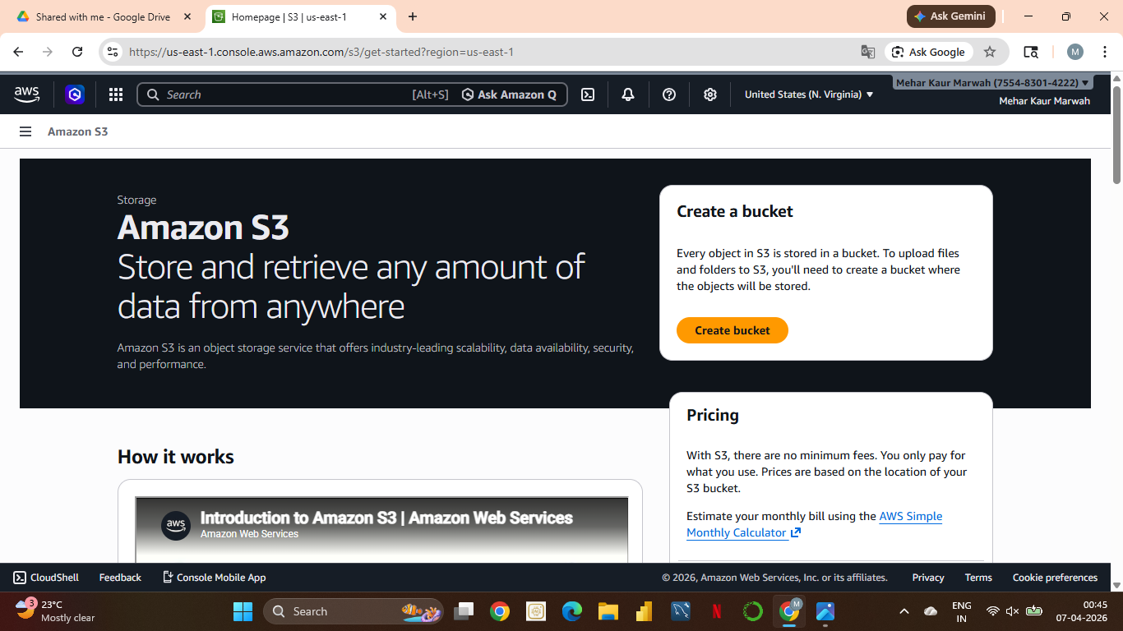
In this we first login into our account as a root user and go to Amazon S3 and then we click on Create Bucket option .
STEP-2
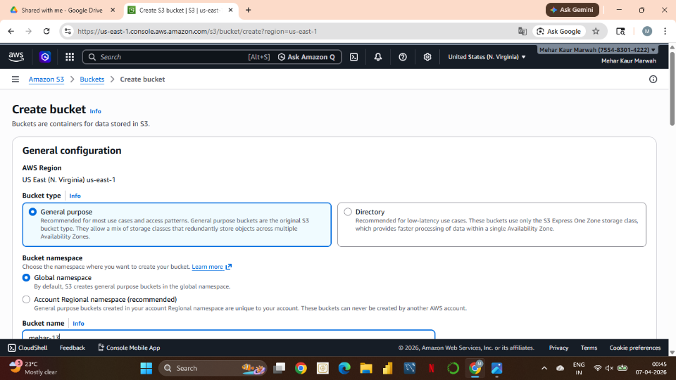
After going in create bucket a new window appears where we create our bucket .We choose General purpose under object ownership.
STEP-3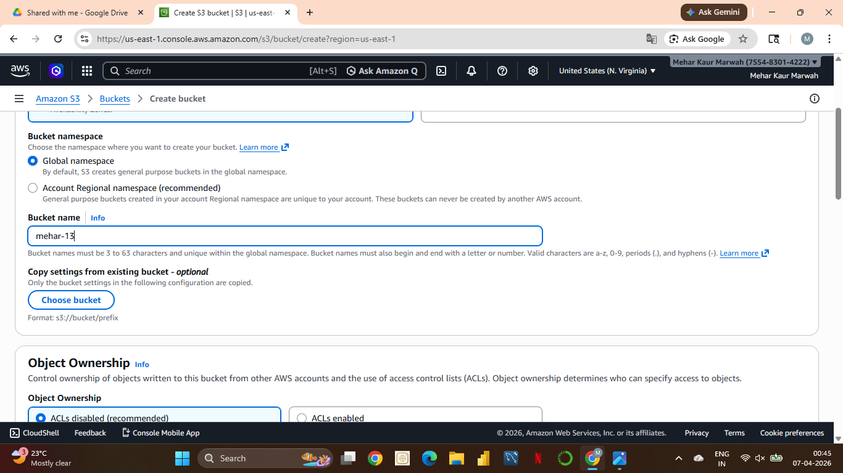
We then name our bucket. Here the name given is mehar-13.
STEP-4
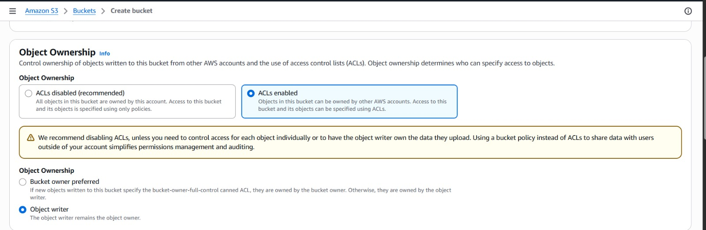
Now we choose ACLs as enabled because we are making a public bucket and in public bucket means owned by anyone or any user can access it . And we also do not choose the checkbox of Block all Public Access as we are making a Public bucket.
STEP-5
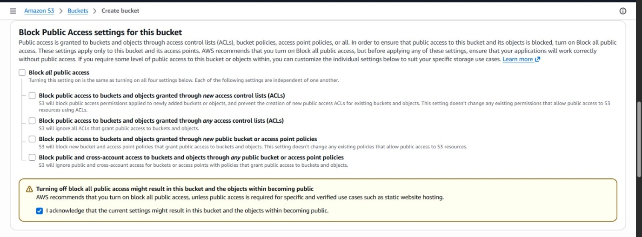
IN this step we turn off Block Public Access button o it has Public access
STEP-6
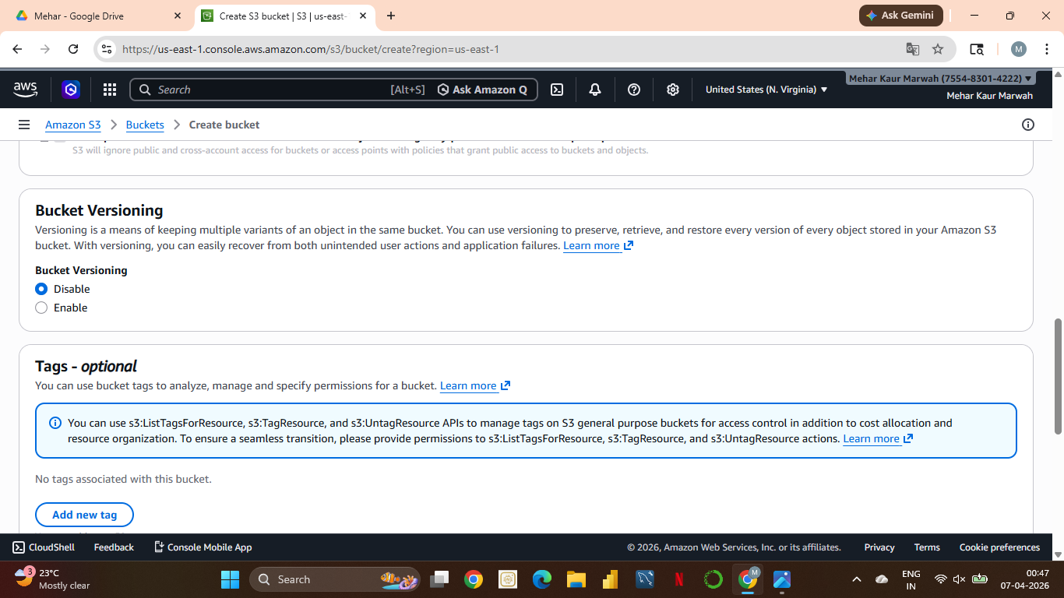
We keep the Bucket versioning and Tags as it is and as we scroll down we click on Create bucket that I on bottom right corner .
STEP-7
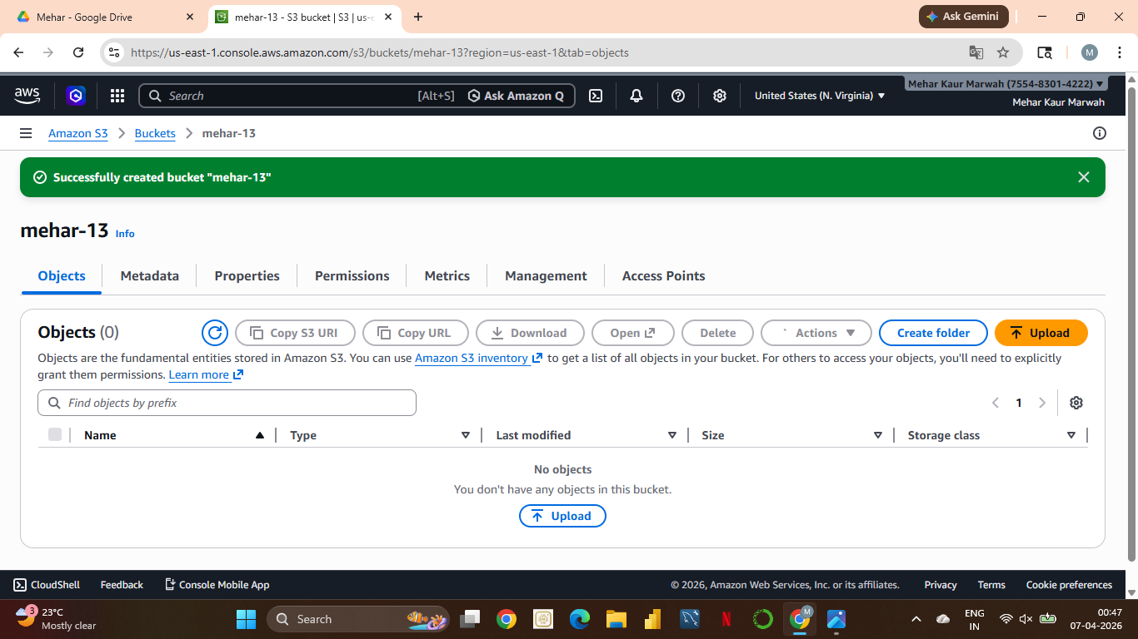
Now we came on o the window of bucket , where our bucket has been created. Now we see the upload option on right side , here we upload our files/folders .
STEP-8

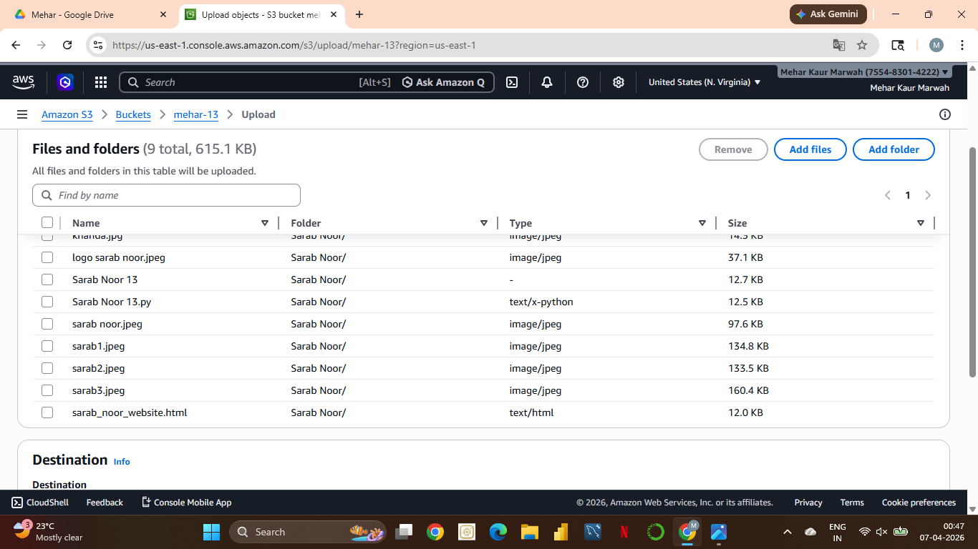
Here I uploaded a folder called Sarab Noor that itself has 9 file in it and then we have to select the checkboxes of the files I want to upload .
STEP-9
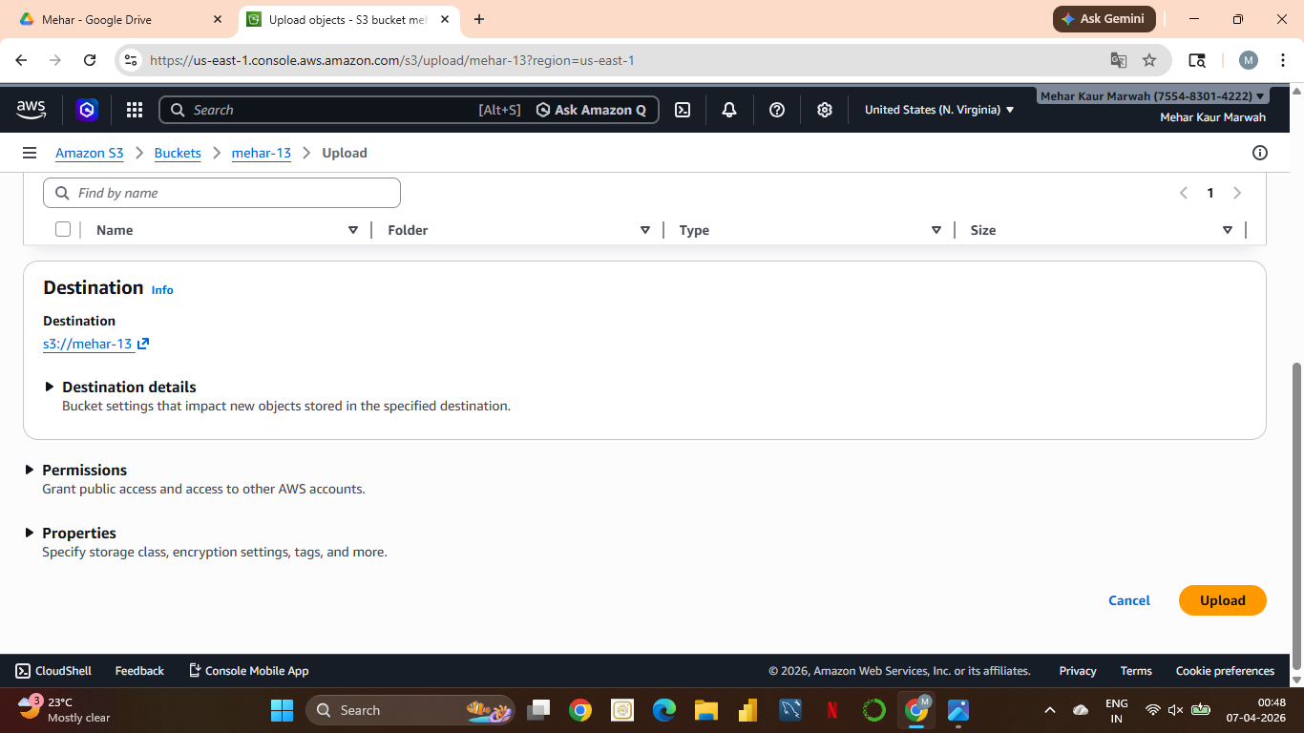
After selecting the files inside our folder we scroll sown ad see an option called Upload.
STEP-10
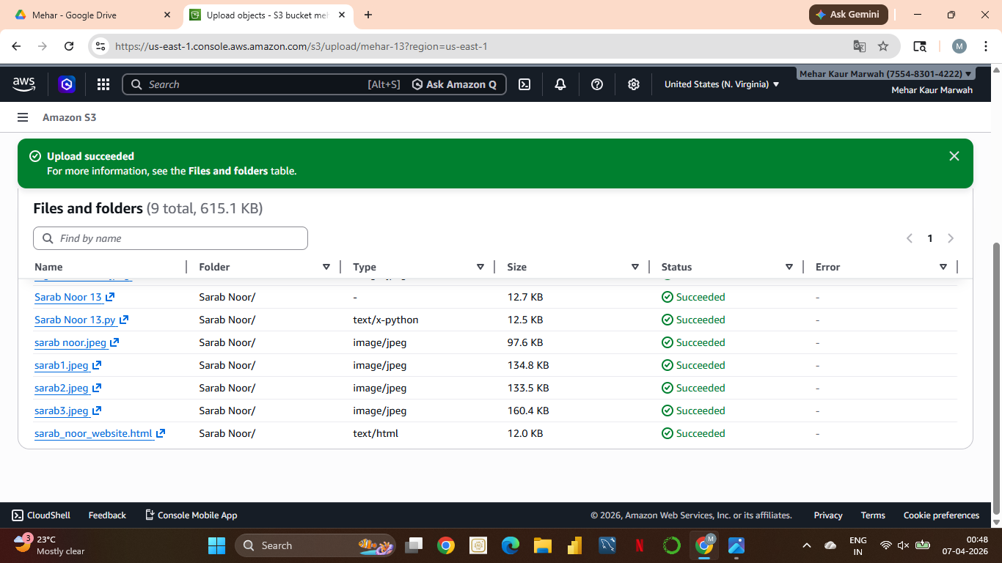
We selected our files an uploaded and we ee hat they have successfully been uploaded.
STEP-11

Then we go to our objects there we see a button called Action we click on it, and click on the option in the scrollbar called Make Public Using ACLs.
And our Public Buket has been successfully created .

